CINNAMON BRIOCHE FRENCH TOAST RECIPE

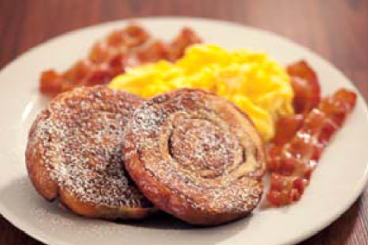
Ingredients
4 ea Eggs
1 cup Half and Half
2 Tbsp Sugar
¼ tsp Salt
¼ tsp Vanilla
¼ tsp Cinnamon
4 ea Cinnamon Rolls (pre-cooked and cut in half to create two circles)
Nonstick spray (such as Pam)
Powdered Sugar
Directions
Heat griddle or non‐stick pan to medium heat.

In mixing bowl combine eggs, half and half, sugar, spices and orange zest and whisk until well
combined to make French toast batter.

Dip each cinnamon roll in French toast batter until moist, but well drained.

Spray griddle or nonstick pan with non‐stick spray and place dipped French toast on griddle. Let brown approximately 2 minutes, flip and griddle other side another 2 minutes.

Place 2 pieces of French toast on plate, sprinkle with powdered sugar and serve with maple
syrup and butter.

